**ANS:1**

Query:

Table Creation:

create table Riders(

rdr_id int primary key,

rname varchar(35),

vehicle varchar(40),

vtype varchar(2),

join_date date,

total_rides int,

income decimal,

distance decimal

);

create table Passengers(

pid int primary key,

pname varchar(35),

join_date date

);

create table Rides_Today(

rd_id int primary key,

rdr_id int,

pid int,

distance decimal(6,2),

bill decimal

);

Data Population:

insert into riders (rdr_id, rname, vehicle, vtype, join_date, total_rides, income, distance)

values( 1, "Abrar Fahim", "Honda Civic", "C", str_to_date("20-03-2020","%d-%c-%Y"), 75, 87000, 1200),

( 2, "Jafar Ahmed", "Yamaha R15", "B", str_to_date("12-01-2020","%d-%c-%Y"), 55, 60000, 900),

( 3, "Jannatul Lamia", "Toyota Prius", "C", str_to_date("04-04-2020","%d-%c-%Y"), 30, 33000, 350),

( 4, "Tanvir Ahmed", "Yamaha Pulsar", "B", str_to_date("01-12-2019","%d-%c-%Y"), 105, 100000, 1370),

( 5, "Shahriar Alam", "Bajaj Discover", "B", str_to_date("25-01-2020","%d-%c-%Y"), 5, 1000, 80),

( 6, "Ashfaq Nabid", "UM Sprt", "B", str_to_date("28-09-2020","%d-%c-%Y"), 1, 350, 22),

( 7, "SM Sayem", "Toyota Corolla", "C", str_to_date("08-08-2020","%d-%c-%Y"), 15, 5200, 190),

( 8, "Golam Haider", "Vespa", "B", str_to_date("16-03-2020","%d-%c-%Y"), 45, 52000, 650);

insert into passengers( pid, pname, join_date)

values( 1, "Shahriar Chowdhury", str_to_date("02-01-2020","%d-%c-%Y")),

( 2, "Jamal E Mollah", str_to_date("21-10-2019","%d-%c-%Y")),

( 3, "Alvi Hossain", str_to_date("12-11-2020","%d-%c-%Y")),

( 4, "Tonmoy Jaman", str_to_date("27-01-2020","%d-%c-%Y")),

( 5, "Toukir Munshi", str_to_date("02-12-2019","%d-%c-%Y")),

( 6, "Yakub Noby", str_to_date("24-12-2019","%d-%c-%Y")),

( 7, "Mithila Rahman", str_to_date("27-02-2020","%d-%c-%Y")),

( 8, "Jobbar Sheikh", str_to_date("14-03-2020","%d-%c-%Y")),

( 9, "Chunnu Wahidul", str_to_date("07-06-2020","%d-%c-%Y")),

( 10, "Rakib Hasan", str_to_date("29-08-2020","%d-%c-%Y"));

insert into rides_today( rd_id, rdr_id, pid, distance, bill)

values( 1, 1, 7, 14.3, 480),

( 2, 2, 10, 1.3, 40),

( 3, 4, 2, 8.9, 110),

( 4, 5, 4, 15.5, 260),

( 5, 7, 3, 5.1, 250),

( 6, 1, 7, 14.3, 510),

( 7, 1, 1, 9.5, 330),

( 8, 7, 6, 5.5, 280),

( 9, 8, 10, 8.2, 140),

( 10, 4, 8, 5.7, 90),

( 11, 2, 2, 3.4, 90),

( 12, 8, 6, 12.5, 165),

( 13, 4, 8, 15.6, 250),

( 14, 3, 6, 8.5, 290),

( 15, 4, 2, 5.1, 70);

Screenshots:

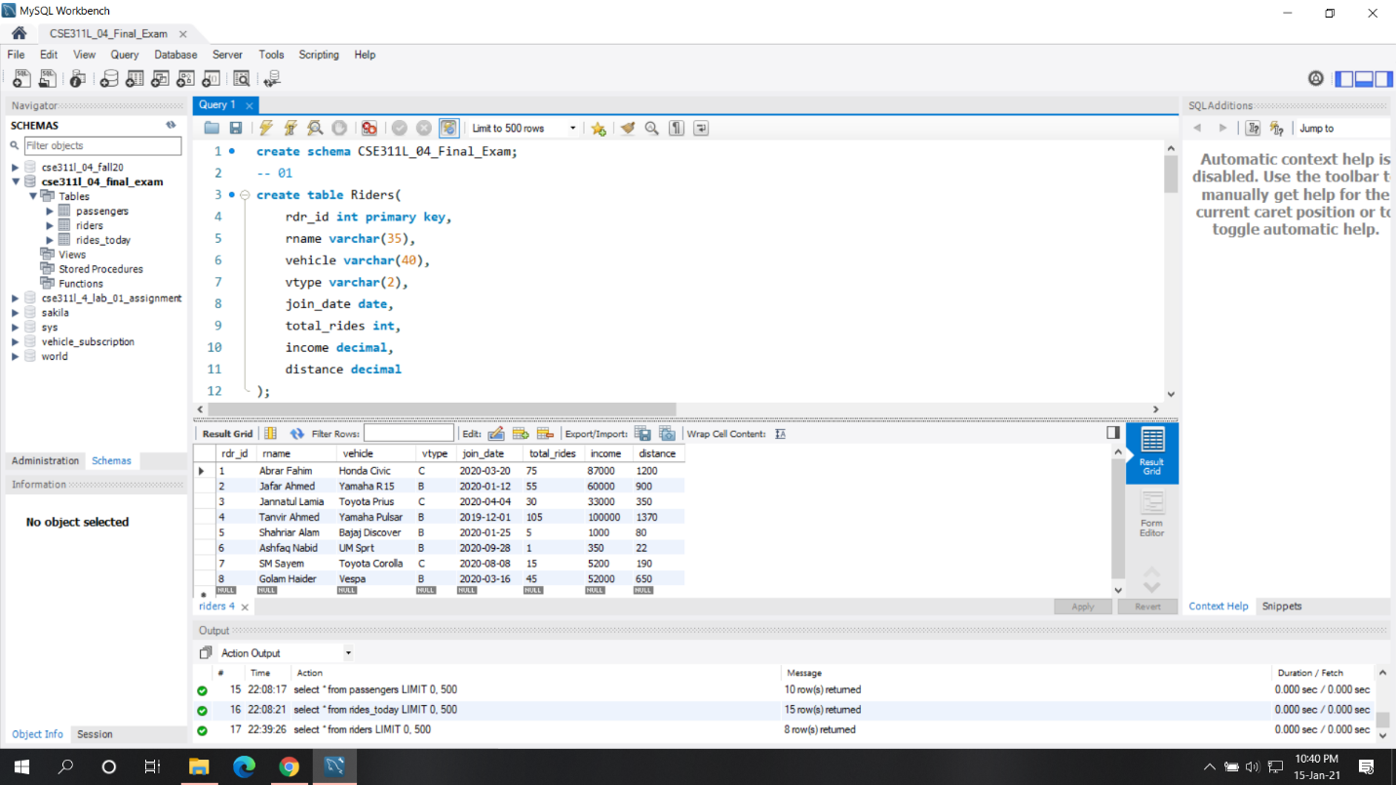

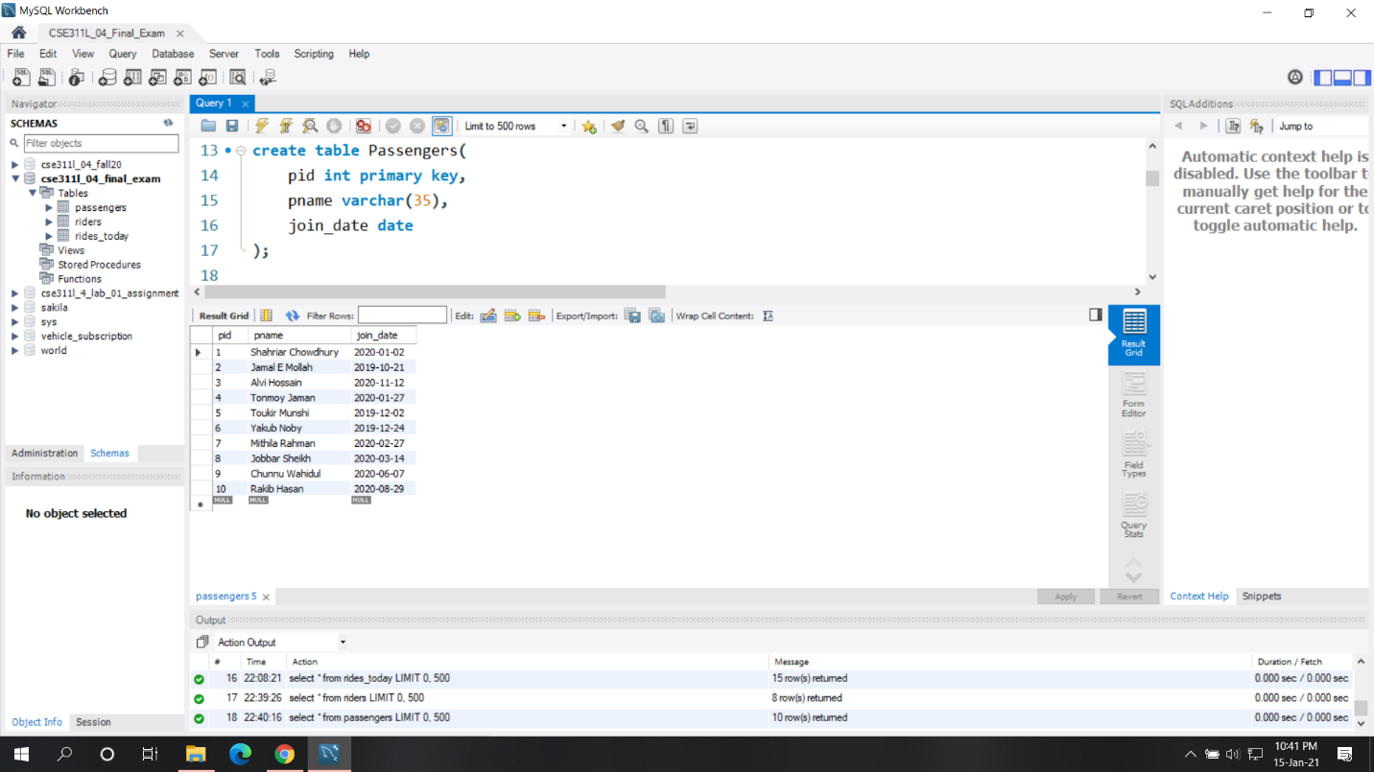

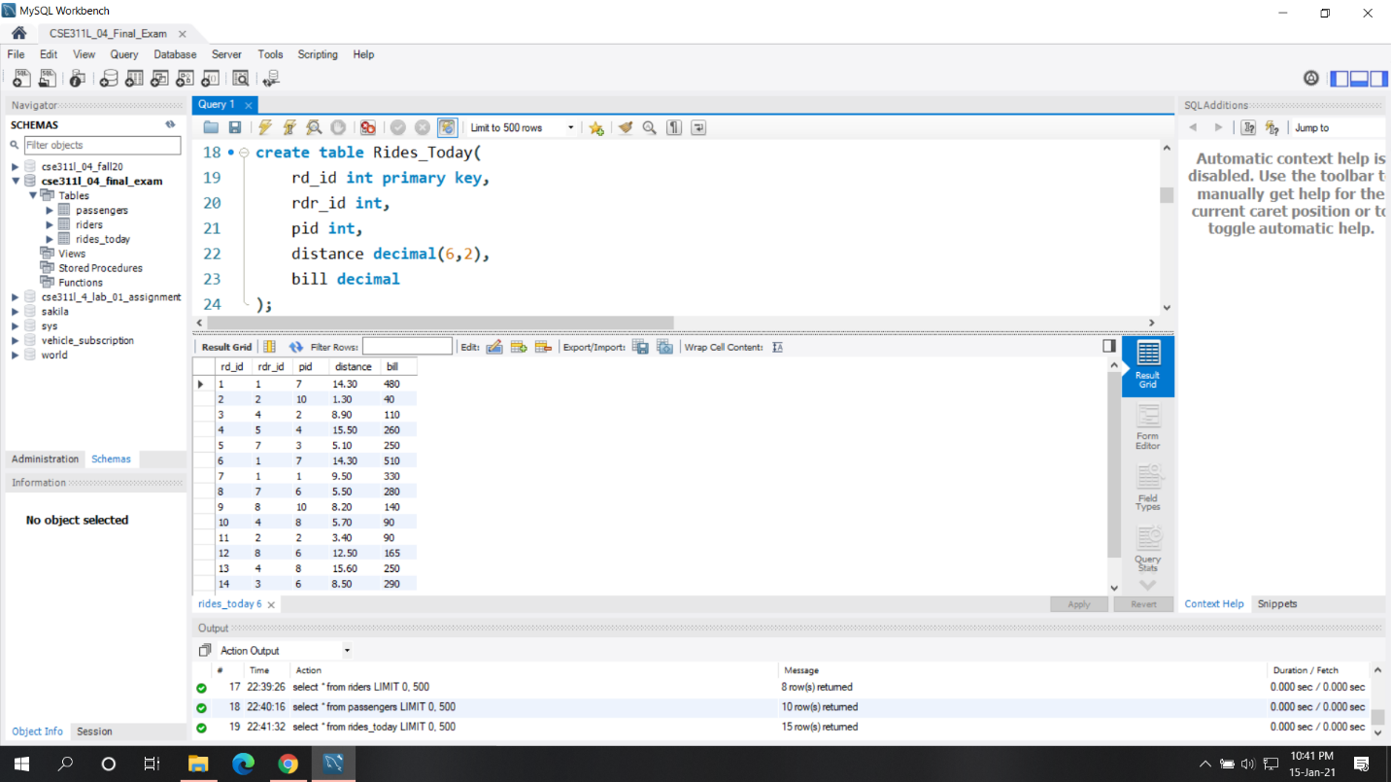

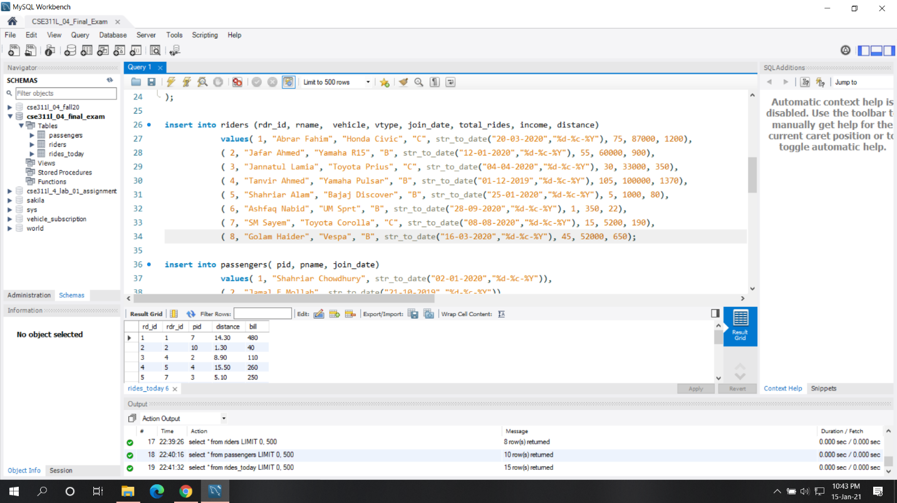

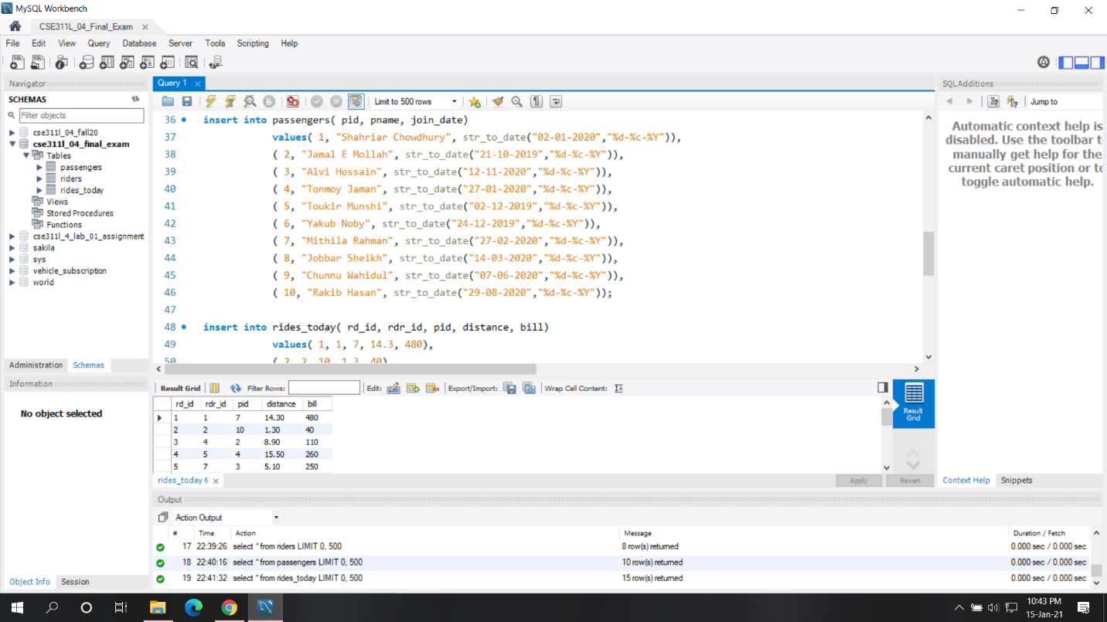

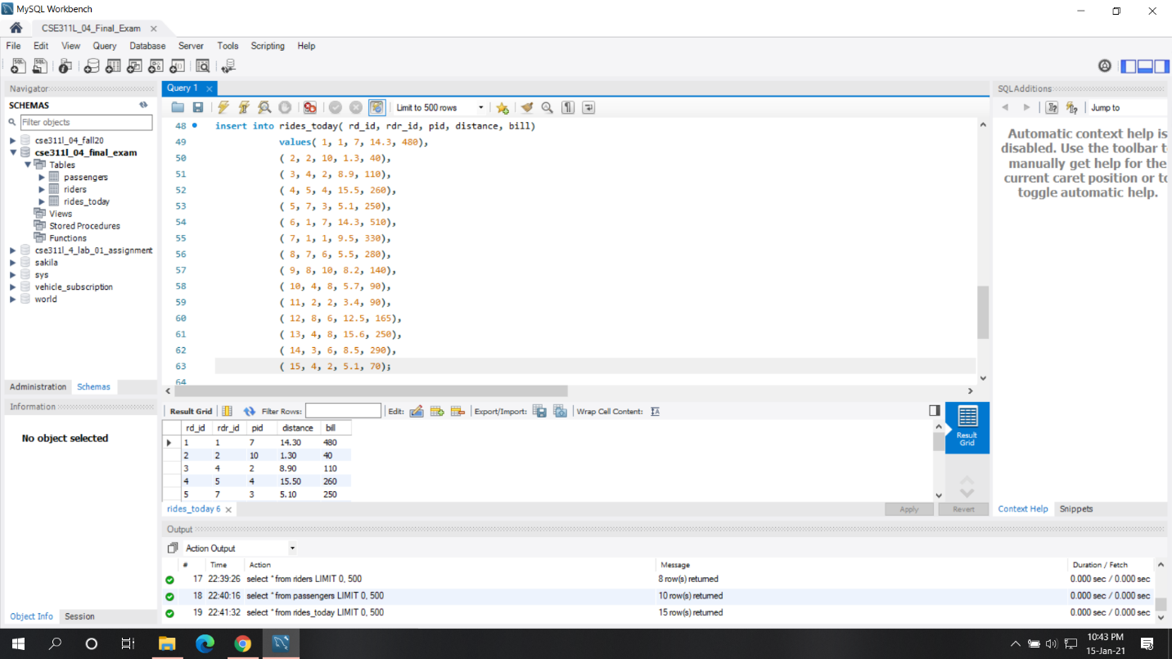

**ANS:2**

Queries:

describe passengers;

describe riders;

describe rides_today;

select * from riders;

select * from passengers;

select * from rides_today;

Screenshots:

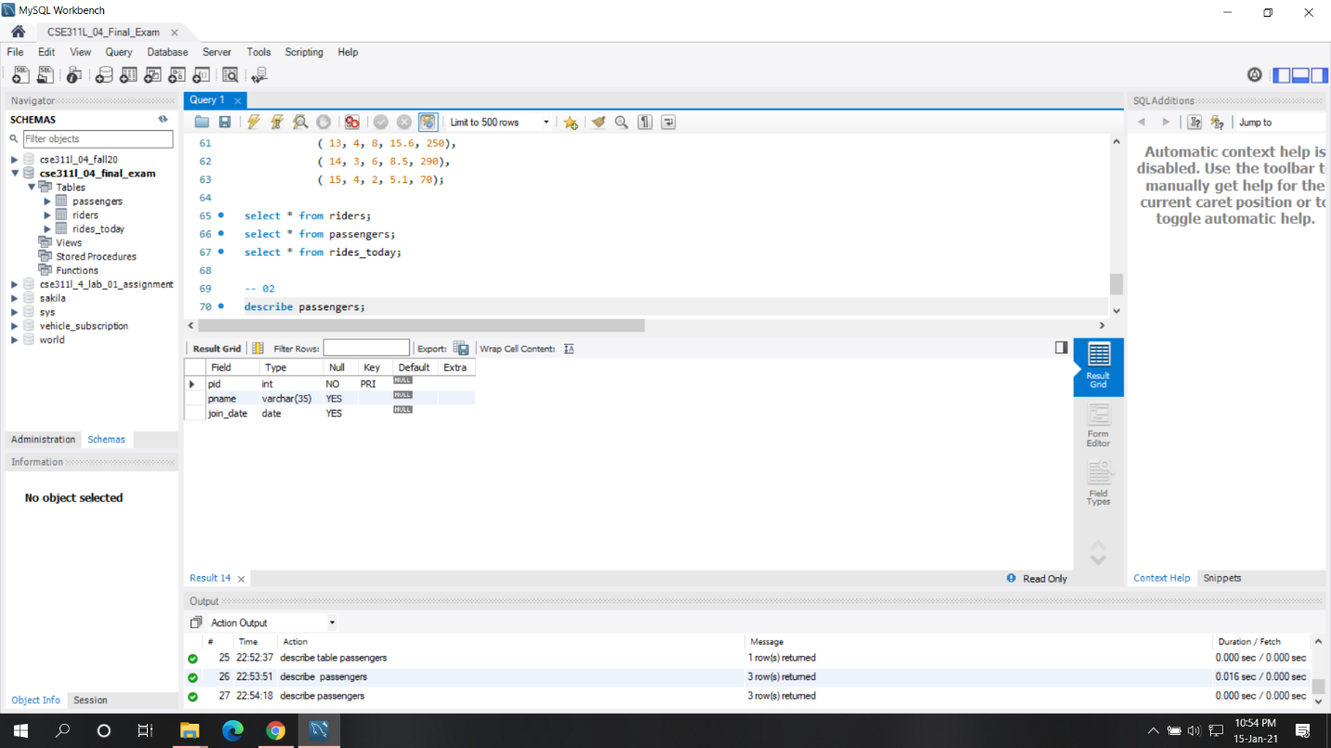

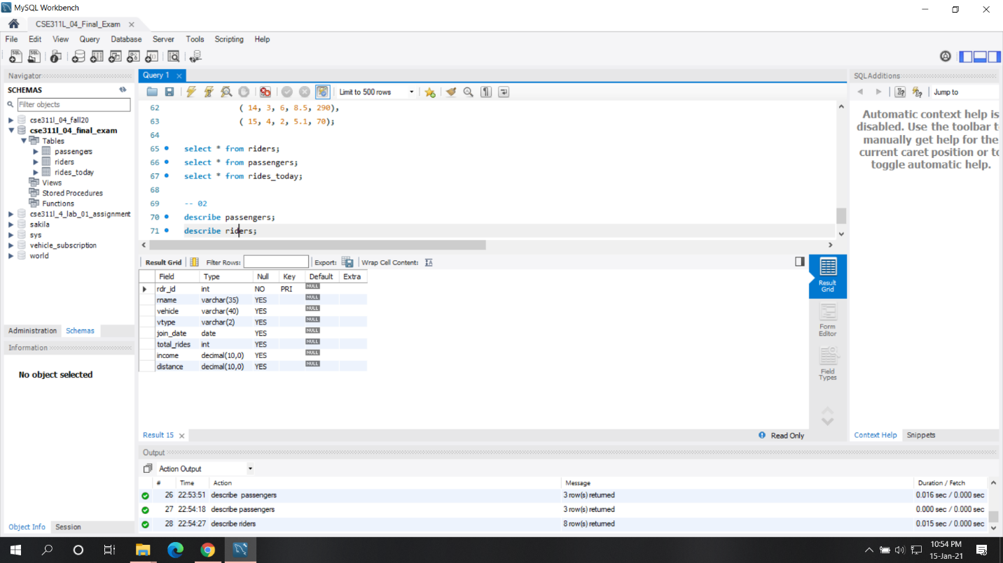

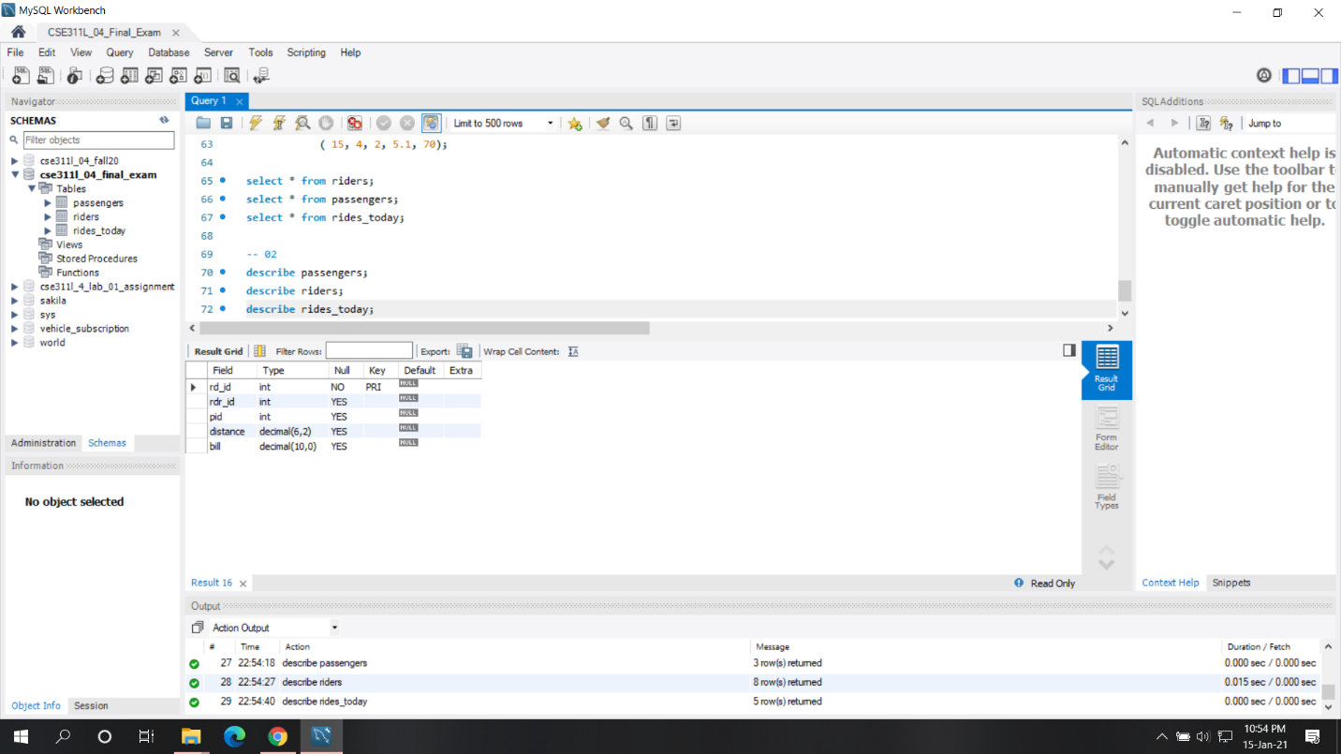

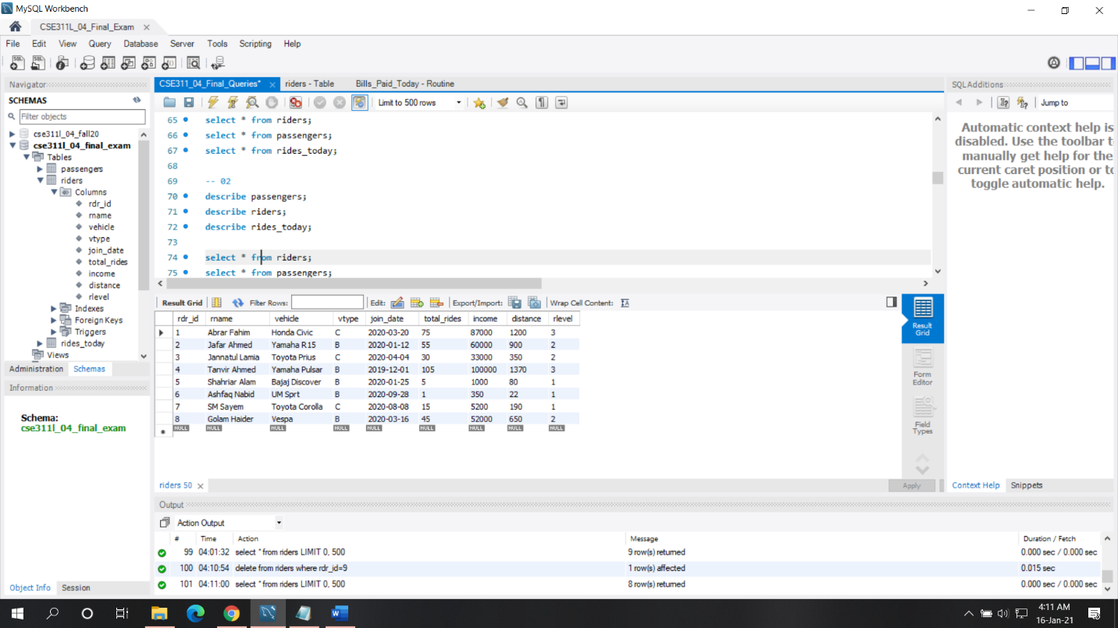

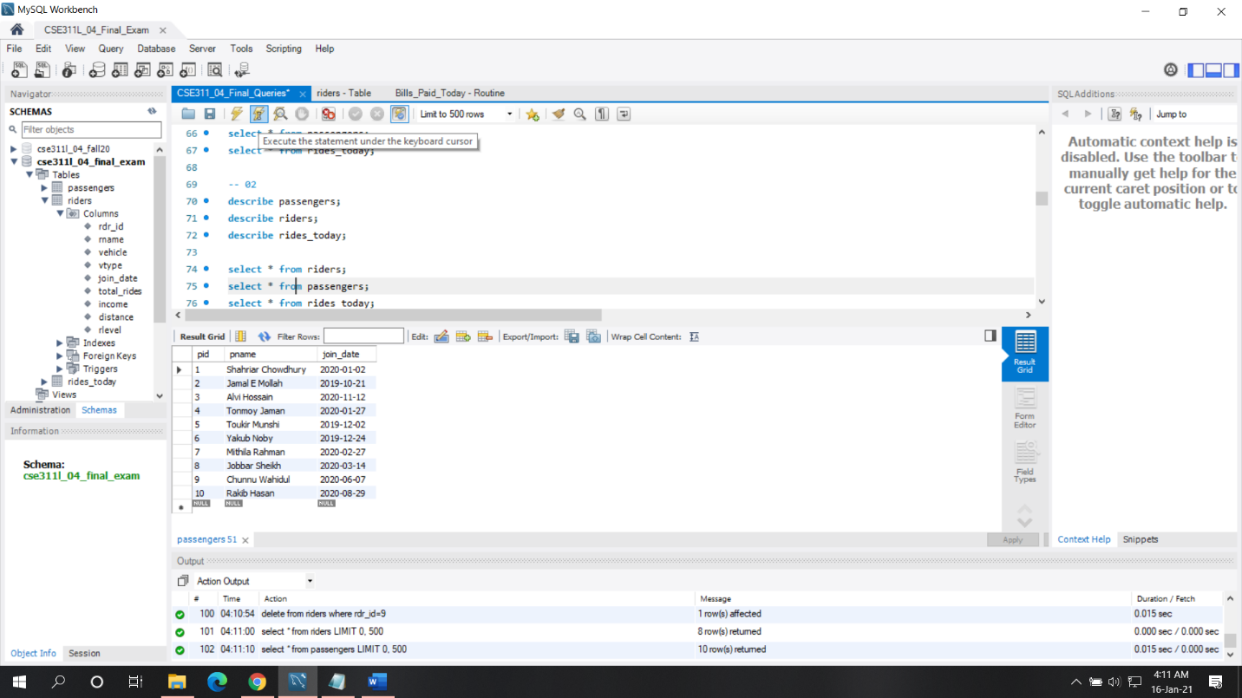

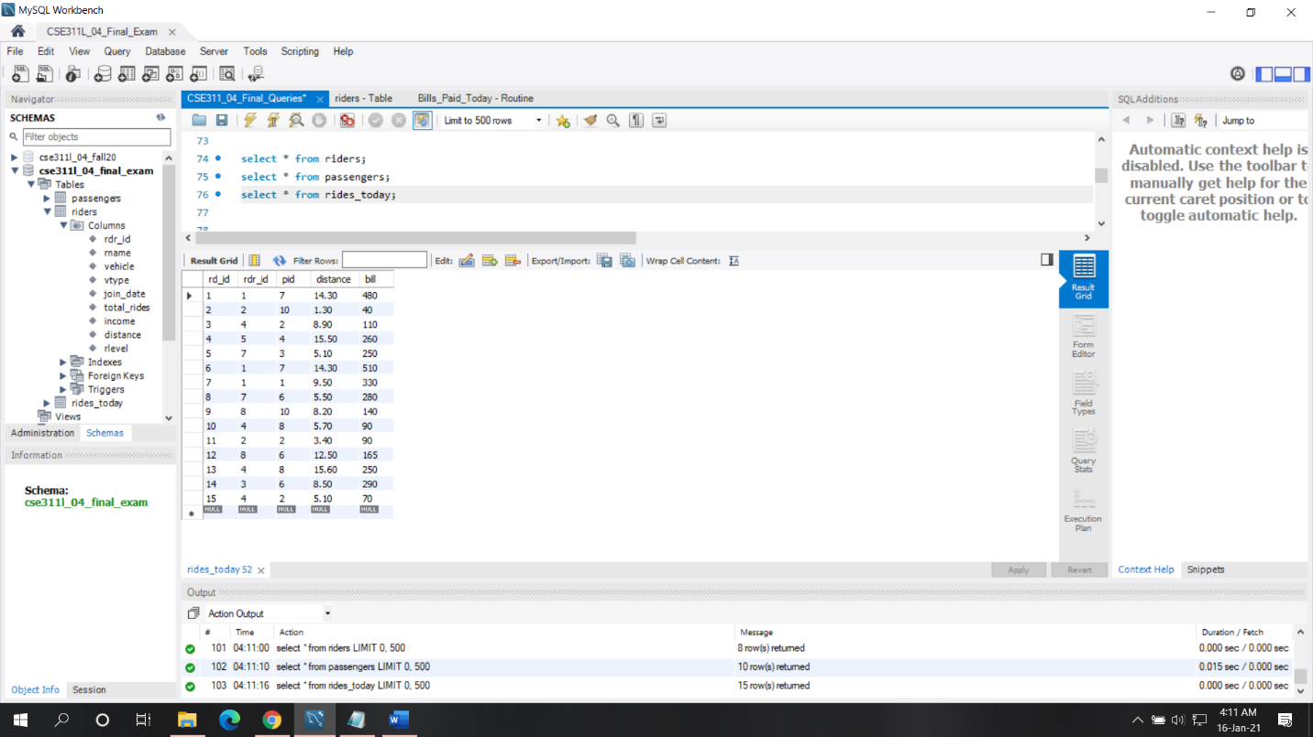

**ANS:03**

Queries:

select rdr_id, rname

from riders

where rdr_id not in( select distinct rdr_id from rides_today);

Description and Explanation:

This question asked to show those riders information who did not ride today.

It is a solvable problem and I have solved this problem by giving a condition where those rider’s id does not present in the rides_today table.

Screenshot:

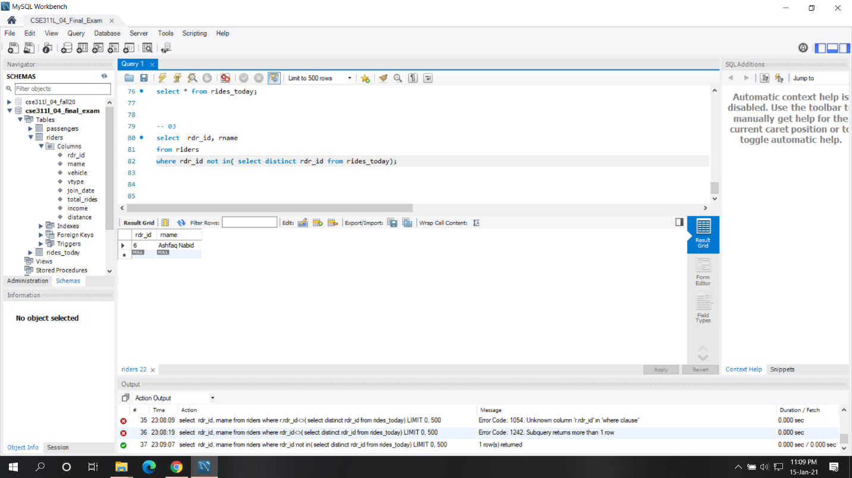

**ANS:4**

Query:

select r.rdr_id "Rider's ID", r.rname "Rider's Name", p.pid "Passenger's Id", p.pname "Passenger's Name"

from riders r

join rides_today rd

on r.rdr_id = rd.rdr_id

join passengers p

on rd.pid = p.pid;

Description and Explanation:

Here we asked to show the details of today’s rides with the rider’s and passenger’s related information about which rider went for the ride today. It was also a solvable problem and to solve the problem I joined all the three tables on a condition where rider’s id and passenger’s id is present on the rides_today table.

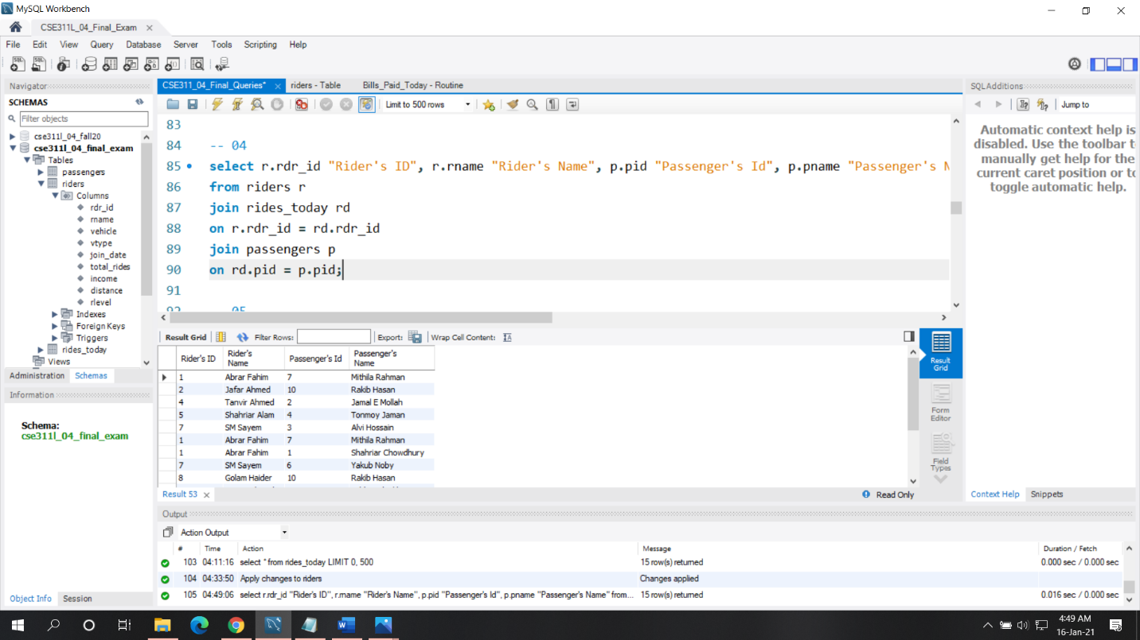

**ANS:5**

Query:

select SUM(bill) "Toay's Revenue From Bikes"

from rides_today rd

join riders r

on rd.rdr_id = r.rdr_id

where r.vtype = "B";

Description and Explanation:

Here we have asked to show the total revenue earned today from bikes. So, I have this problem by joining riders table and rides_today table on the condition of riders’ id of riders table is present on rides_table where they have bikes as vehicle type then just summed their earnings.

Screenshot:

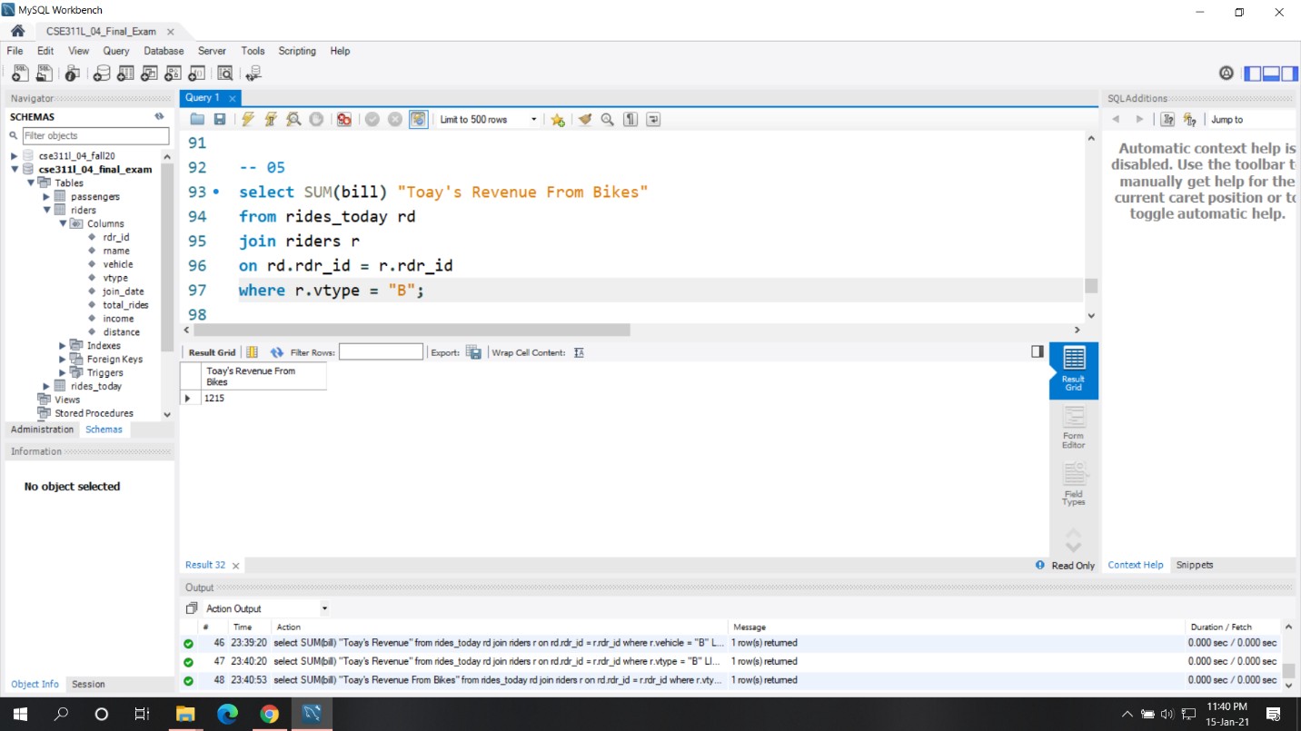

**ANS:06**

Query:

select r.rname "Rider's Name", r.vehicle, rd. distance "Shortest Distance Travelled by Bike"

from riders r

join rides_today rd

on r.rdr_id = rd.rdr_id

where r.vtype = "B" and rd.distance = (select min(rd.distance)

from rides_today rd

join riders r

on rd.rdr_id = r.rdr_id

where r.vtype = "B");

Description and Explanation:

Here we have asked to find all the bikes with its rider’s name who drove the shortest road. I have solved this problem by joining riders table and rides_today table on the condition of riders’ id of riders table is present on rides_table where vehicle type is bike and its ride the shortest distance which is measured by a sub query.

Screenshot:

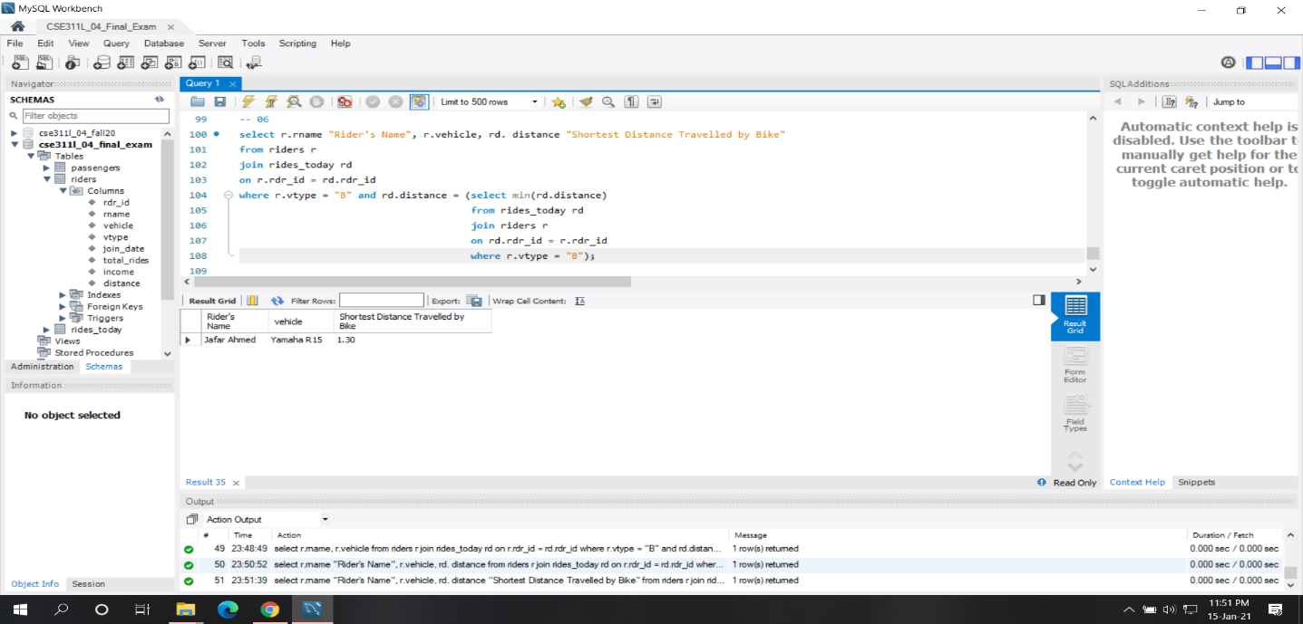

**Ans:07**

Query:

select r.rname "Car Rider's Name", r.vehicle, rd. distance " Distance Travelled by Car"

from riders r

join rides_today rd

on r.rdr_id = rd.rdr_id

where r.vtype = "C" and rd.distance <10;

Description and Explanation:

Here we have asked to find all the car riders who drove less than 10km. I have solved this problem by joining riders table and rides_today table on the condition of riders’ id of riders table is present on rides_table where vehicle type is car and its ride less than 10km.

Screenshot:

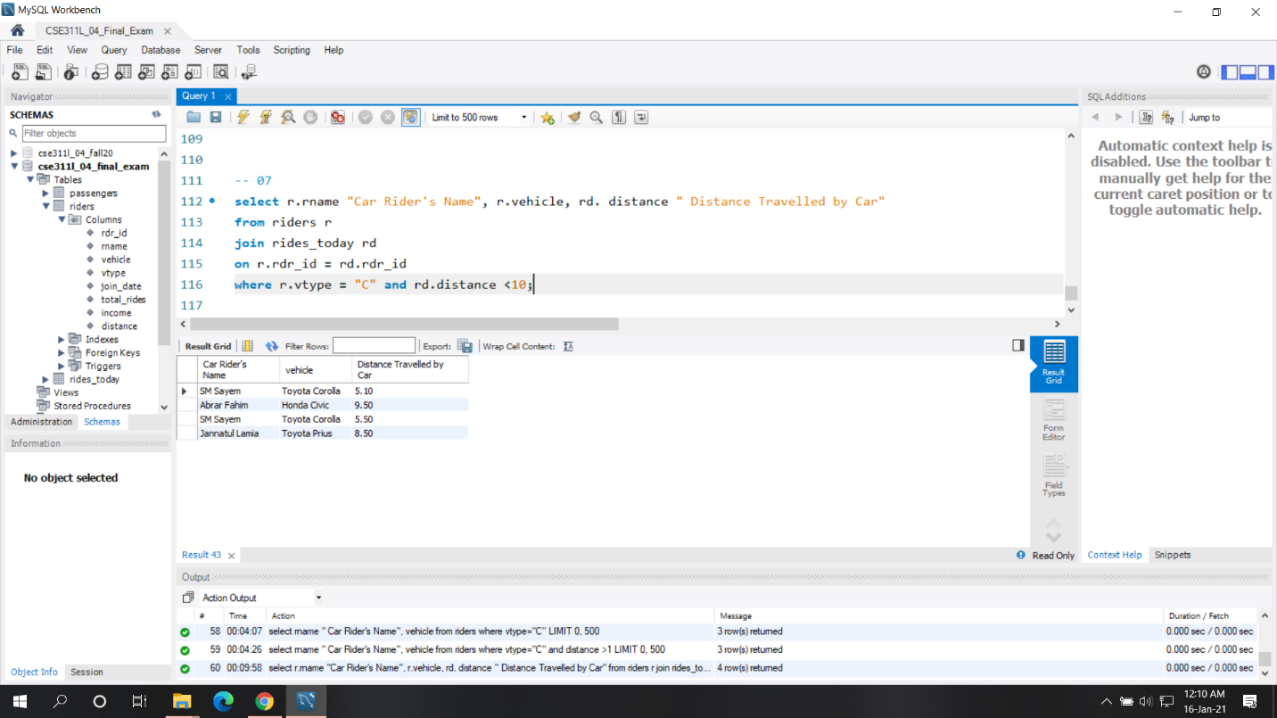

**ANS:08**

Query:

select r.rname "Rider's Name", r.vehicle, sum(rd.bill) "Earned Today"

from riders r

join rides_today rd

on r.rdr_id = rd.rdr_id

group by rd.rdr_id;

Description and Explanation:

Here we have asked to find how much each rider earned today. I have solved this problem by joining riders table and rides_today table on the condition of riders’ id of riders table is present on rides_table then just group them by the rider’s id of rides_table .

Screenshot:

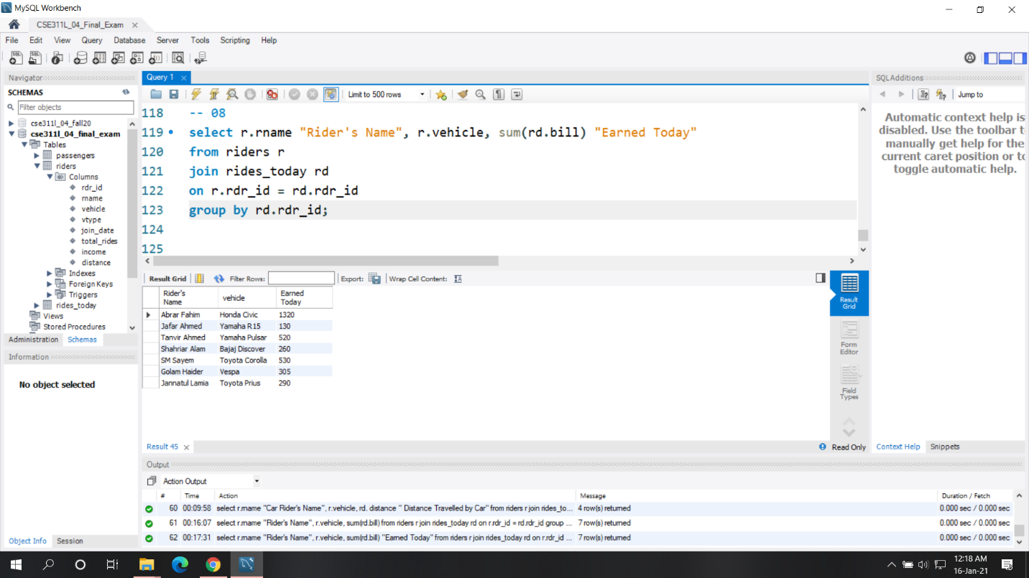

**ANS:09**

Query:

alter table riders

add (rlevel int);

Screenshot:

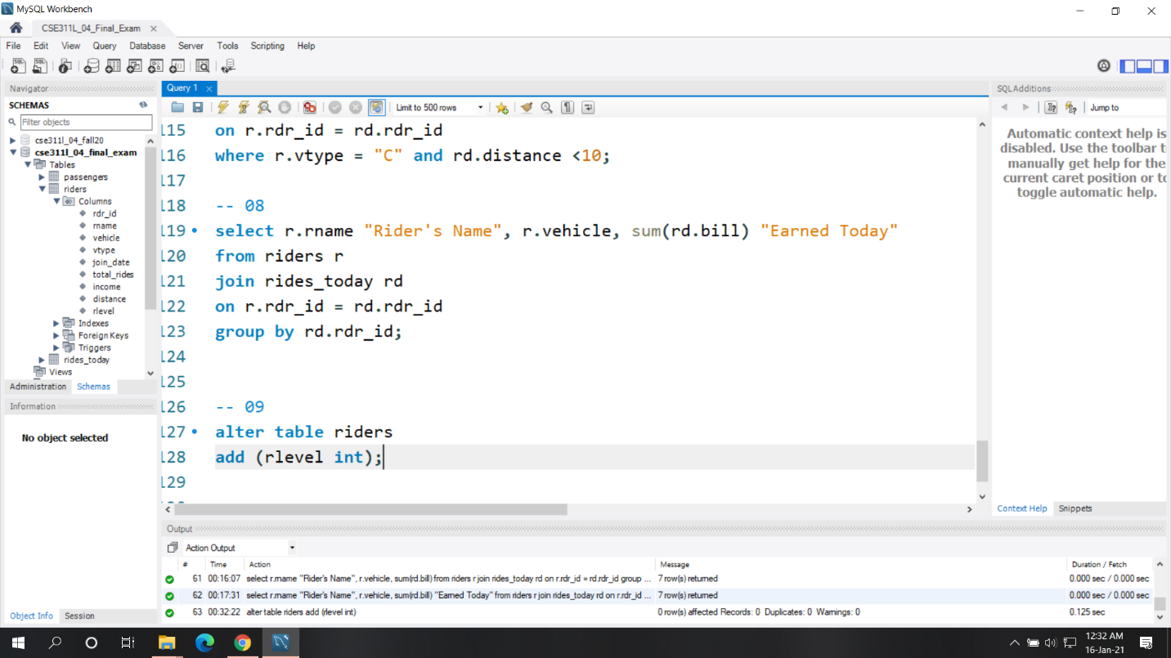

**ANS:10**

Query:

update riders

set rlevel = 1

where total_rides <30;

update riders

set rlevel = 2

where total_rides <70 and total_rides >30 ;

update riders

set rlevel = 3

where total_rides >70 ;

select * from riders;

Description and Explanation:

Here we have asked to update the rider’s table rlevel column by some condition. I have solved this problem just update that rlevel column using the given condition.

Screenshot:

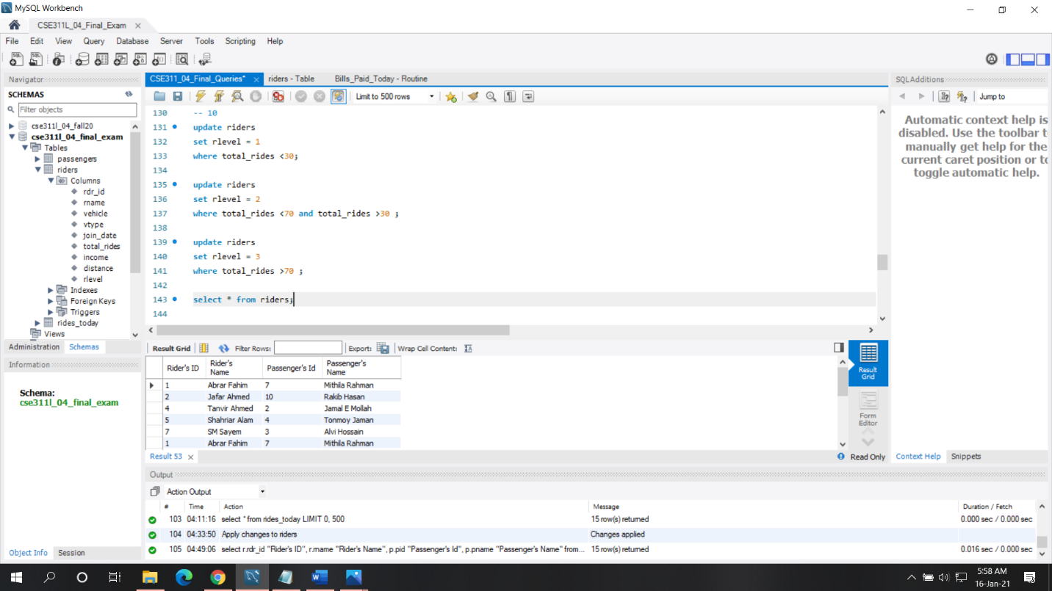

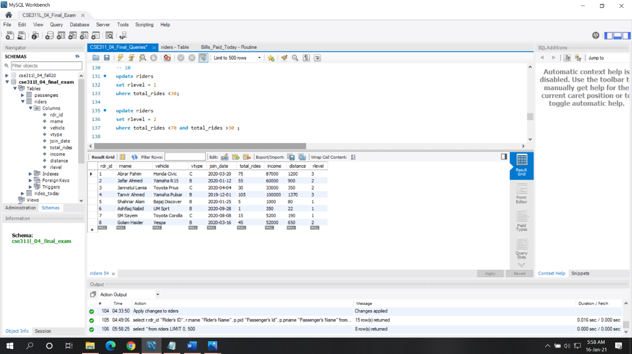

**ANS:11**

Query:

CREATE DEFINER=`root`@`localhost` TRIGGER `riders_BEFORE_INSERT` BEFORE INSERT ON `riders` FOR EACH ROW BEGIN

if new.total_rides <30 then

set new.rlevel = 1;

elseif (new.total_rides<70) and (new.total_rides>30)then

set new.rlevel = 2;

elseif (new.total_rides >70) then

set new.rlevel = 3;

end if;

END

Description and Explanation:

Here we have asked to create a trigger that will automatically insert value in rlevel column when anything will be insert in riders table. I have solved this problem by using the condition mentioned in number 10 question in if else condition then just set the new value in rlevel column for every new entries in riders table and here our trigger will be triggered before inserting any row in rider’s table.

Screenshots:

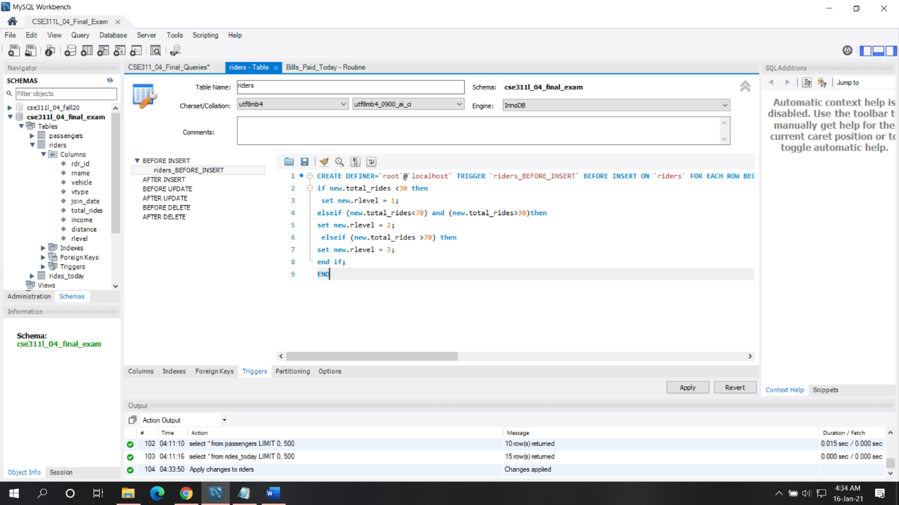

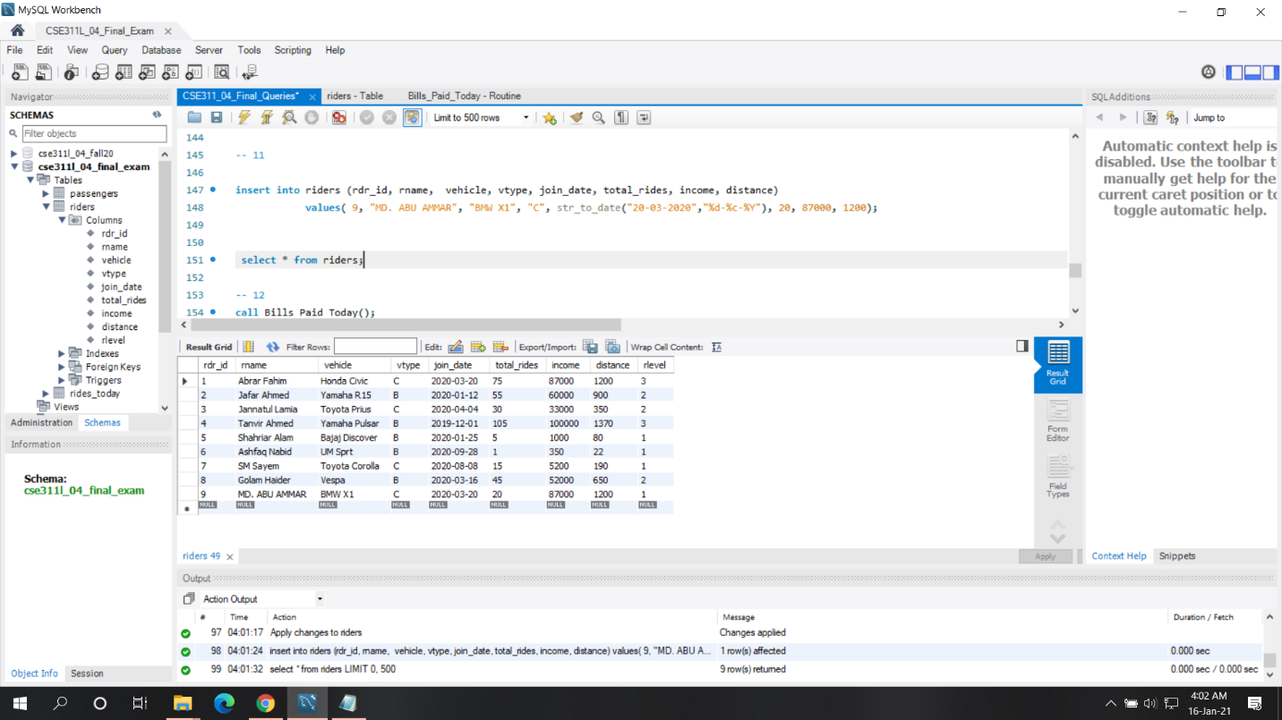

**ANS:12**

Query:

CREATE DEFINER=`root`@`localhost` PROCEDURE `Bills_Paid_Today`()

BEGIN

select p.pname "Passanger Name", sum(rd.bill) "PAid Today"

from rides_today rd

join passengers p

on p.pid = rd.pid

group by rd.pid;

END

call Bills_Paid_Today();

Description and Explanation:

Here we have asked to create a store procedure that will return the total amount of bill each passenger paid today then execute the procedure to show this. I have solved the problem by creating a store procedure where I store a procedure that will return the total amount of bill each passenger paid today where I have joined the passengers table and rides_today table on condition of passengers of passengers table present on rides_today table then just group them by their id.

Screenshots:

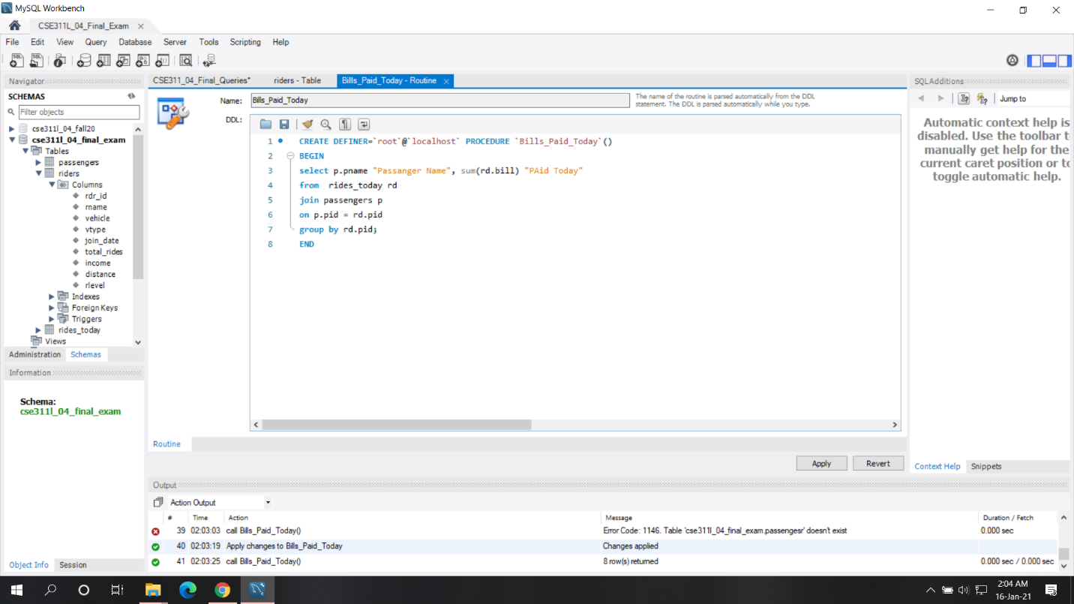

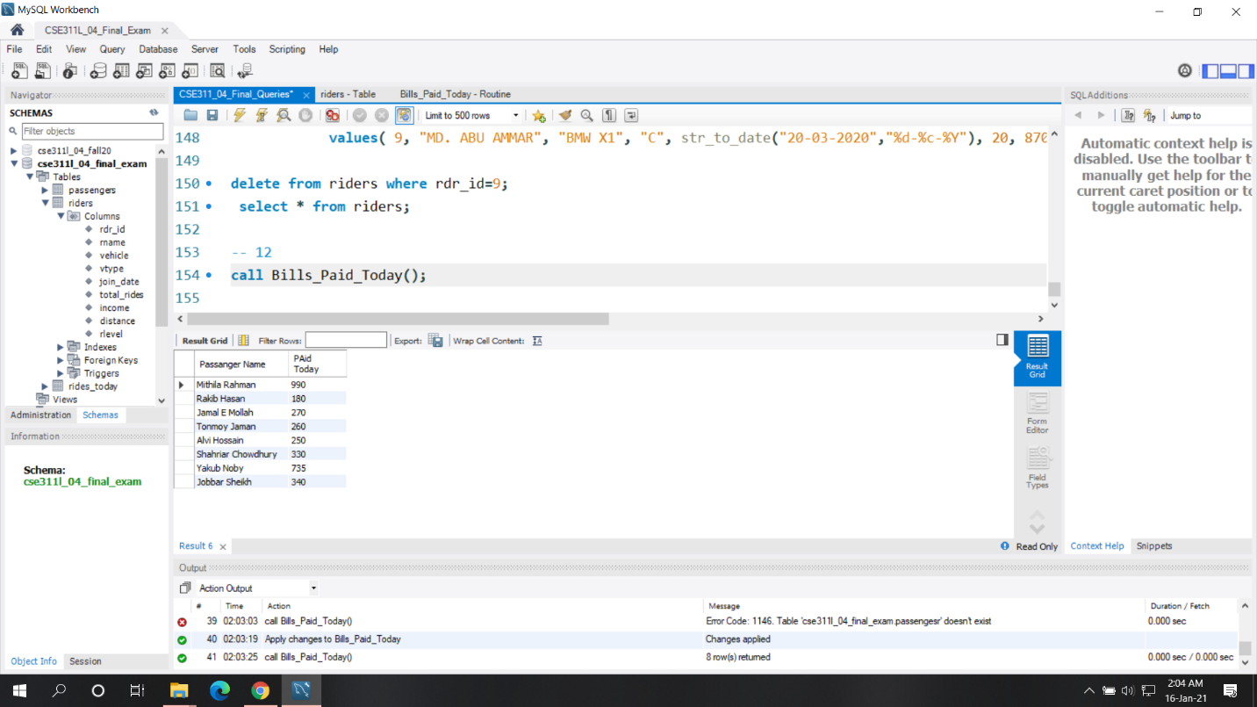

**ANS:13**

Query:

select r.rname "Riders Name", p.pname "Passanger Name", rd.distance, rd.bill

from rides_today rd

join riders r

on rd.rdr_id = r.rdr_id

join passengers p

on rd.pid = p.pid

where r.vtype = "B"

group by rd.rdr_id

having count(rd.rdr_id)<2;

Description and Explanation:

Here we have asked to show the name of bike riders with their passenger name and other info who complete a single ride today. I have solved this problem by joining all the table with the condition vehicle type is bike and the group them by the rider id while they appear only one time in rides_today table.

Screenshot:

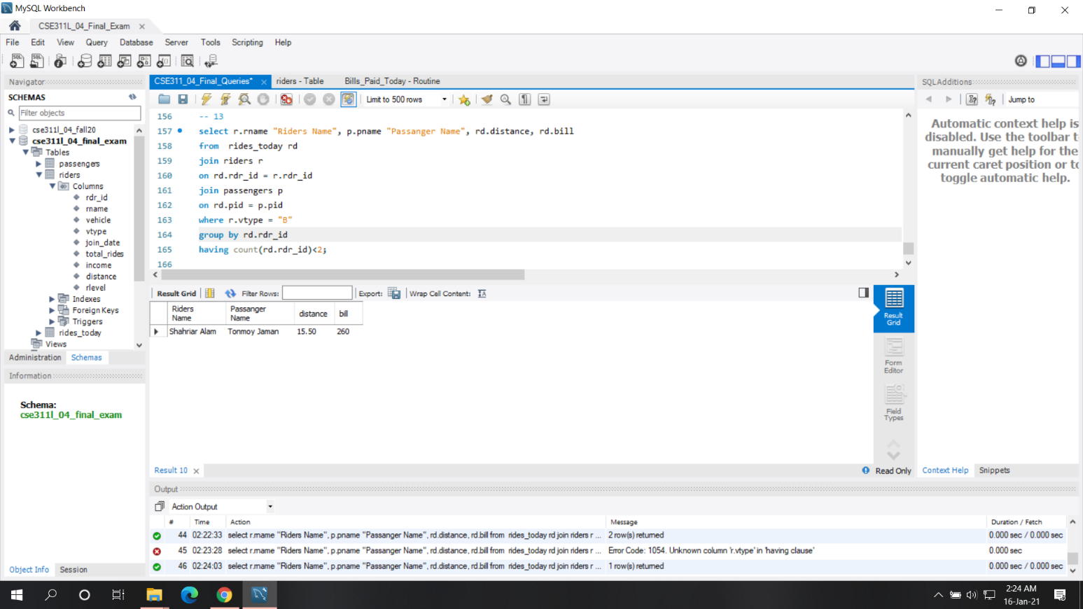

**ANS:14**

Query:

select r.rname "Car Rider's Name", r.vehicle, sum(rd.bill) "Today's Total Income"

from rides_today rd

join riders r

on rd.rdr_id = r.rdr_id

where r.vtype = "C"

group by rd.rdr_id;

Description and Explanation:

Here we have asked to show the name of all car riders with their total income of today. To solve this problem, I just joined the rides_today table and riders table on the condition of riders’ id of riders table is present on the rides_table where vehicle type is car then just group them by them with their id.

Screenshot:

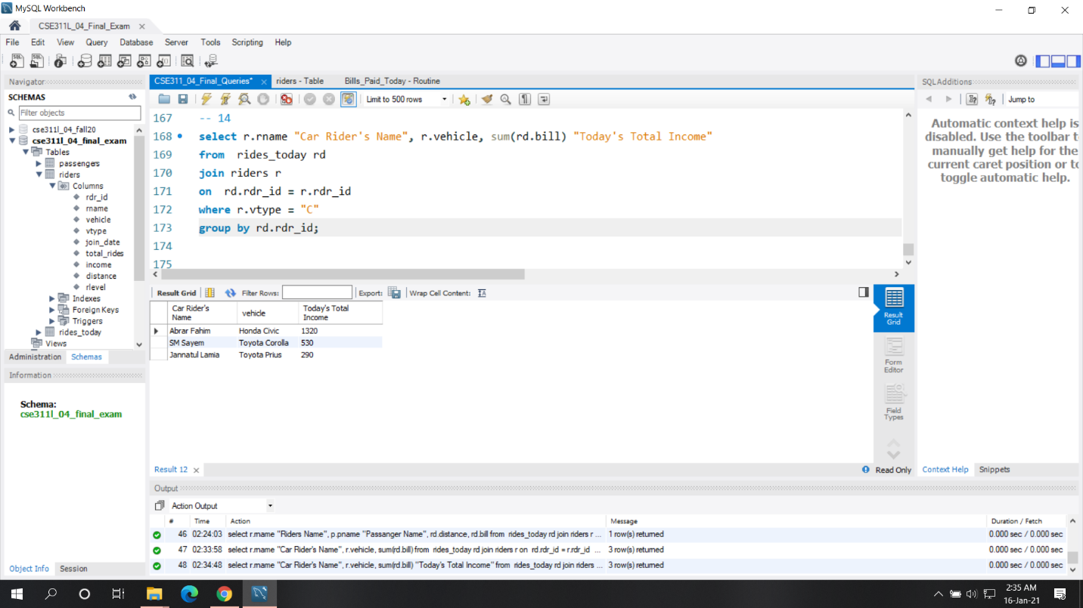

**ANS:15**

Query:

select r.rdr_id "Rider's Id" ,r.rname "Rider's Name", p.pid "Passenger's ID" , p.pname "Passenger's Name", rd.distance, rd.bill

from rides_today rd

join riders r

on rd.rdr_id = r.rdr_id

join passengers p

on rd.pid = p.pid;

Description and Explanation:

Here we asked to show the details of today’s rides with all the rider’s and passenger’s related information. It was also a solvable problem and to solve the problem I just joined all the three tables on a condition where rider’s id and passenger’s id is present on the rides_today table and just fetched the information of both passenger and riders from here.

Screenshots:

